**Activity 1**

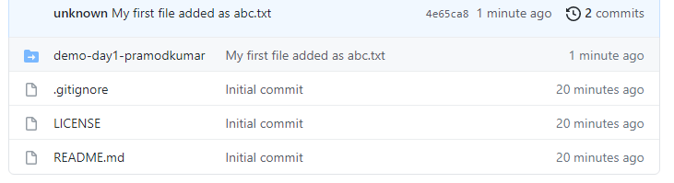

**Activity 2**

